4.1.

GENERATED IP: 190.114.188.146/20

A) Network address/Netid: 190.114.176.0

B) Host address/Hostid: 190.114.176.1 – 190.114.191.254

C) IP address class: B

D) Netmask related to the address / (in slash notation) and in dotted decimal form: 255.255.240.0

4.2.

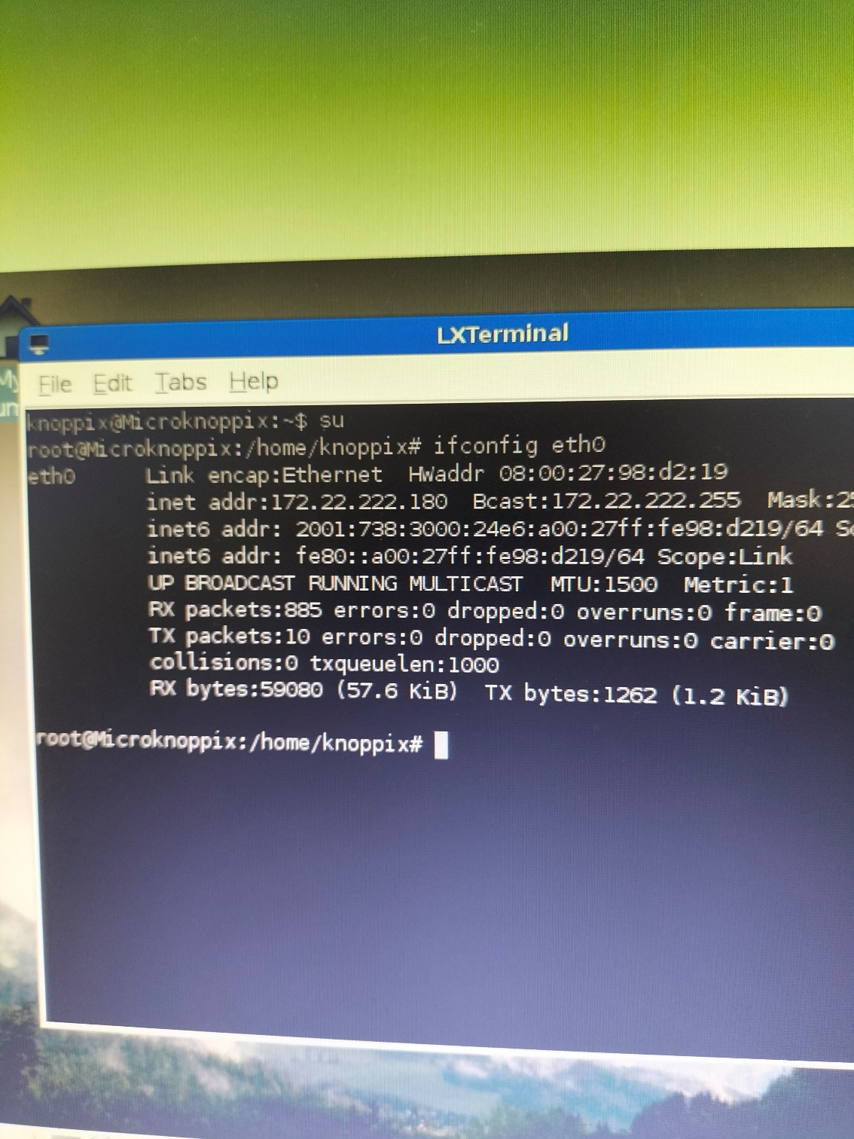

A) What IP addresses did the virtual machines receive in the network?

172.22.222.180

B) How would be possible to change the IP address of the 1st machine for the IP address used in the previous exercise?

Ifconfig eth0 <new ip address>

4.3.

A) What is the physical address of the 1st machine? How can you display this information (by using only linux terminal)?

* The Physical address is also known as the MAC address. The MAC Address is listed as the HWaddr. Hence, the Physical address is 08:00:27:98:d2:19
* Ifconfig eth0

B) What is the name of the manufacturing company assigned to this physical address?

PCS Systemtechnik GmbH

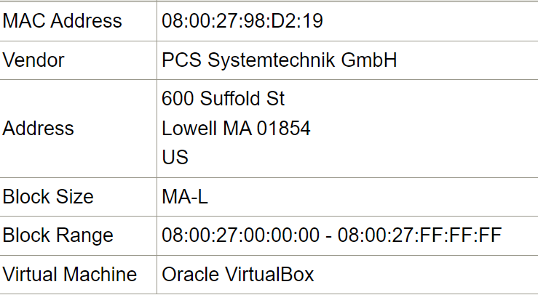

C) What does happen with the ARP table after shutting down the connection and after reconnection?

When a connection is shut down, the ARP entries related to that connection are typically removed from the ARP table. When reconnected, the ARP process begins again. The system will send out ARP requests to learn the MAC addresses of the IP addresses it needs to communicate with. As it receives ARP replies, it will populate the ARP table with the new mappings.

D) Which command did you use precisely to insert a new entry to the arp table?

sudo arp -s <ip-address> <mac-address>

E) Which command did you use precisely to delete a static entry from the arp table?

sudo arp -d <ip-address>

4.4. A) Fill in the following table:

|  | | SOURCE | DESTINATION |
| --- | --- | --- | --- |
| (3) | IP | 128.119.199.43 | 128.119.248.227 |
| MAC | 6D-14-64-A8-8B-4D | 92-52-31-C4-F5-35 |
| (2) | IP | 128.119.199.43 | 128.119.248.227 |
| MAC | 6D-14-64-A8-8B-4D | 89-D9-AC-73-20-EF |
| (1) | IP | 128.119.199.43 | 128.119.248.227 |
| MAC | 6D-14-64-A8-8B-4D | 89-D9-AC-73-20-EF |

B) Explain what is the role of the physical address and that of the IP address in the network communication. Which type of address can be used in what cases (when)?

Physical Address is a unique identifier assigned to network interfaces for communications at the data link layer of a network segment. In simple terms, the Physical address is like the unique physical mailing address of your house. It’s used for delivering packets on a local network or within a subnet.

IP Address is a numerical label assigned to each device participating in a computer network that uses the Internet Protocol for communication. An IP address serves two main functions: identifying the host or network interface, and providing the location of the host in the network. It is used for routing packets over the Internet or between subnets.

When they can be used:

* Physical Address: This is used when transmitting frames on the local network segment. For example, when a device wants to send a packet to another device on the same network, it uses the MAC address of the destination device.
* IP Address: This is used when transmitting packets across network segments (i.e., routing). For example, when a device wants to send a packet to a device on a different network, it uses the IP address of the destination device.

In summary, MAC addresses operate at the data link layer (Layer 2) of the OSI model and are used for local transmission, while IP addresses operate at the network layer (Layer 3) and are used for global transmission.